How to Post Ivy Tech Grades in Campus Connect

- Log into Campus Connect. If you have not logged in for 60 days, you will want to click on reset password to create a new password before you can log in.
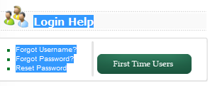

http://cc.ivytech.edu/cp/home/displaylogin

- After you are logged into Campus Connect, click on Final grades.
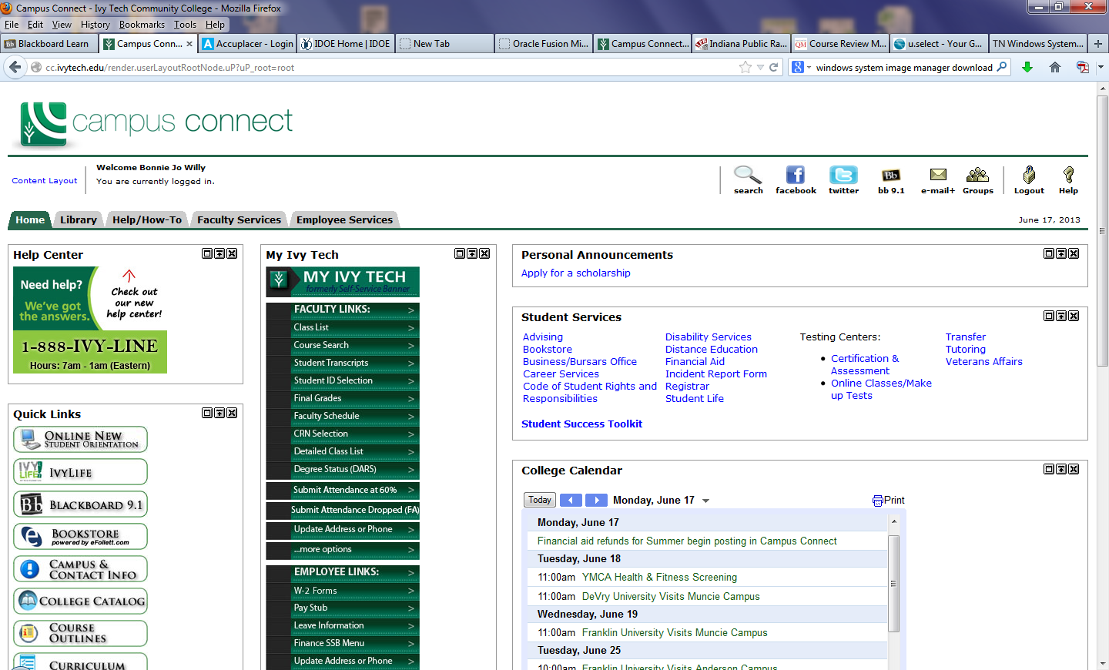

- Select the current term. If it is a year-long course, it will be posted as Spring.
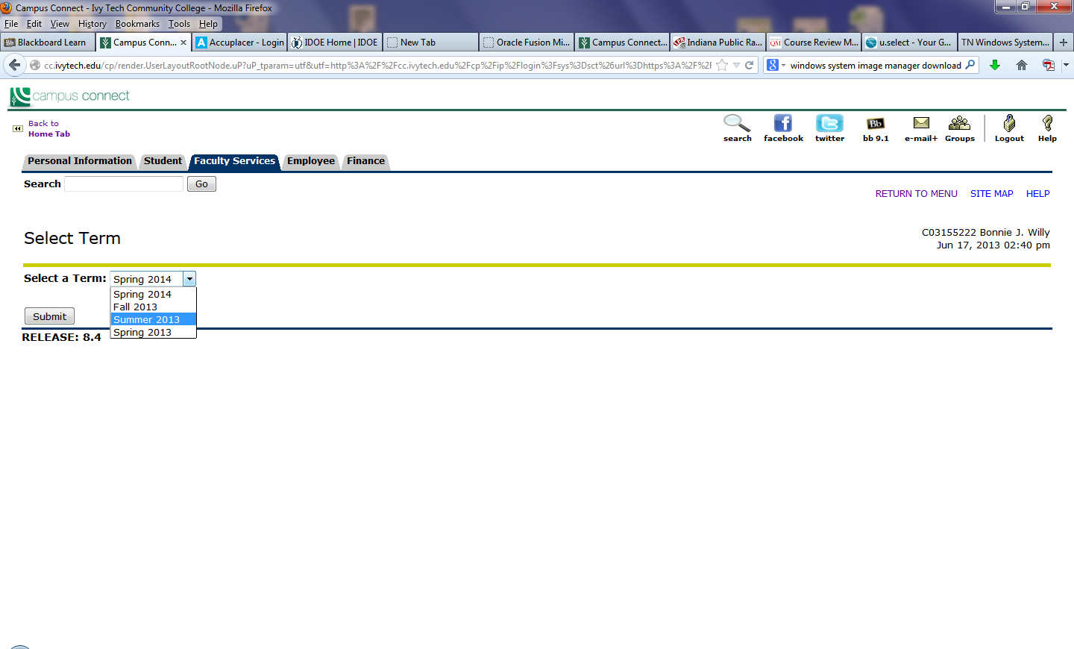
- Click on your course in the dropdown menu. 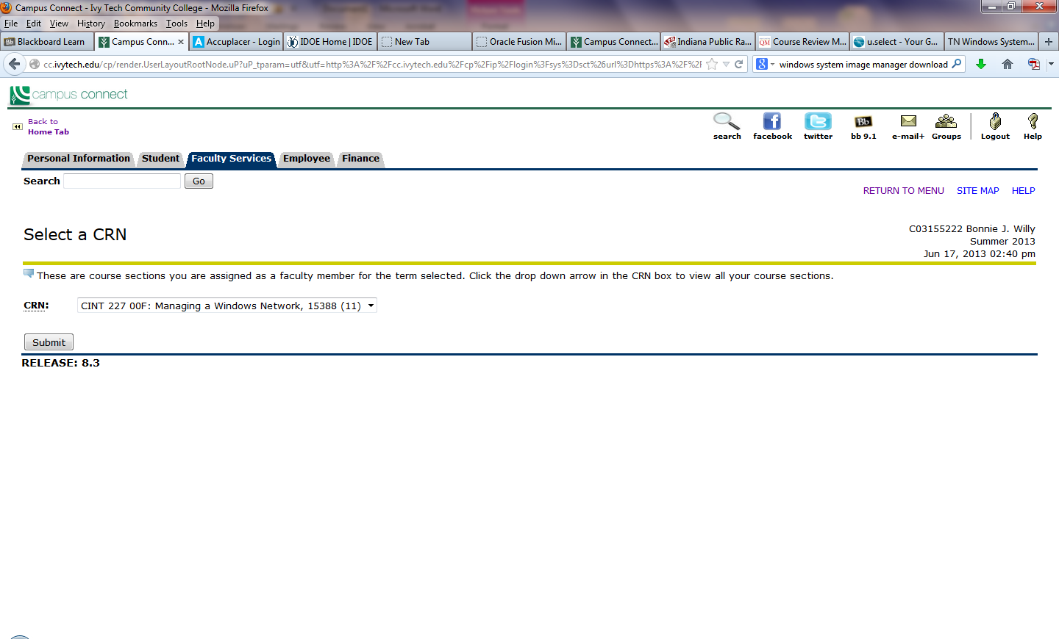
- Do you have any withdrawals, D or F’s? If so, leave the grade as none. Otherwise, select a grade A-C. Do not use any other items in this box. To withdraw students, email bwilly@ivytech.edu saying “please withdraw these students: ________”

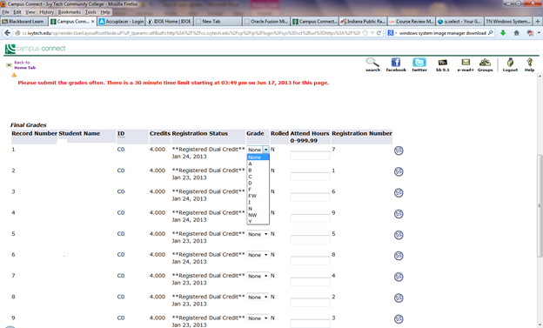
A
B
C
NONE

- Click SUBMIT when you are finished posting all grades.

Email bwilly@ivytech.edu “grades DONE”

If you have students who need to be withdrawn, be sure to list them in the email “please withdraw these students: ________”

