Step 7: (Part 1 of 2) College Search
Kuder
- Choose one job that you have researched in Steps 5 and 6. In that job, go under the ‘Education and Experience Tab.’

- You will see two titles--Suggested Instructional Programs and Suggested College and Postsecondary Majors.

Do the following three times

1.)Choose a major or instructional program. Then, select the ‘Overview’ tab.
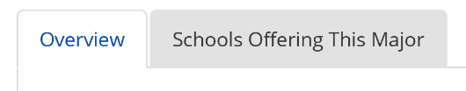

    - Write a brief summary of the overview.

  - 2.) Click on the ‘Schools Offering This Major’ tab.
    - For all of the Indiana schools, list the school, program name, degree/certificate type, city. If there are more than 5 schools, only list 5.
    - Select two non-Indiana colleges and list the above information.

